

**Sri Lanka Institute of Information Technology**

User Research Plan – Lab Sheet 04

**SE3050 – User Experience Engineering – 2021**

Group ID: 2021S2_REG_WE_62

Submitted by:

1. IT19164304 – Ramanayake A.R.D.Y.Y
2. IT19159454 – Fernando P.P.A
3. IT19022116 – Prasad R.M

Contents

Introduction 3

Test Objectives 3

Methodology 4

Interviewing 4

Video Recording 5

Questionnaire 5

Participant Profiles 12

User Research – Task/ Scenarios 13

Plan for Data analysis 14

Interviews 14

Video Recordings 15

Questionnaires 16

# Introduction

This report contains a thorough elaboration of the user research conducted for the e-channeling mobile application. E-channeling is a mobile e-commerce application that has been developed to facilitate online channeling of a doctor's search by a doctor's last name, specialization, and/or hospital name. Users can access their channel history and book the same doctor from there. Lab reports can be viewed by users. Users can order drugs by adding a prescription and the payments for such orders can also be settled through the application itself.

Thus, we hope to identify the key points that have caused the user experience within this to be lacking through methodical research, specifically bugs associated with function flow, interface issues, currently lacking functions, upgrades required for available functions, currently available but not needed functions, and issues related to the attractiveness of the application.

The research is primarily conducted through contextual inquiry, and thus the data collected will be used to confirm and highlight the key usability issues, as well as identify the approach that could resolve the issues. As a result, we will try to provide solutions to the application's issues and improve User Experience by redesigning the application to meet the exact needs of the customer. Then, enhance the user interfaces, user flow experience, and navigation paths.

# Test Objectives

* Identify the failure points in the chosen application.
* Identify the issues that users encountered while using the application.
* Identify whether the chosen application solves the user's problem.
* Identify the user's new feature suggestions.
* Obtain feedback from users on the application.

# Methodology

The user research was carried out after two people were chosen from the list of personas. The user experience research methods chosen were user interviews and customer feedback gathered via a distributed Google form. These methods were less expensive, simpler, and more effective than more expensive methods such as usability lab studies or ethnographic field studies, which were either much more expensive or time-consuming.

# Interviewing

Two people who best matched the personas were chosen and interviewed online, covering all the three members' functionalities. Each interviewee was interviewed by two members. The interviews were recorded for future use. (Because the interviews were conducted online, recording was much easier.)A script was prepared ahead of time to ensure that all aspects of the test objectives were covered. The questions asked during the interview were mostly closed-ended to keep the focus on the issue at hand. However, open-ended questions allowing the user to express their opinion were also asked.

## Script 01

1.Can you share bit of yourself?

2.Have u use any service on this e-channeling app?

3.What do you think about the user friendliness of this application?

4.What do you think about the usability of this application?

5.What are the other services you have experienced in this app other than channeling a doctor?

6.According to your perspective what improvements you suggest doing?

7.If we consider the overall functionality, performance and design what do you think about this app?

## Script 02

## Tell about yourself?

## Have you ever used e channeling app?

## Can you say for what ?

## Do you think this e-channeling app is better than comparing to manual doctor channeling or not?

## Have you ever used drug delivery section of this app?

## what are the difficulties you have faced during drug delivery and channel a doctor?

## what do you think about the performance of this application? Is it good or worst?

# Video Recording

Participants for the interview will be asked to join for an online interview session through the Microsoft Teams application, where the interview will be recorded from start to end in order to keep evidence of customer experience and feedback.

# Questionnaire

A questionnaire was distributed as a Google form, with most questions having quantitative answers to make data analysis easier. The purpose of the first section was to learn about the demographics of the users. In this section, general questions like age and gender were asked to see if there was a link between the users' demographics and how they felt about the application. The sections that followed covered the application's major functionalities, with a focus on the user experience.

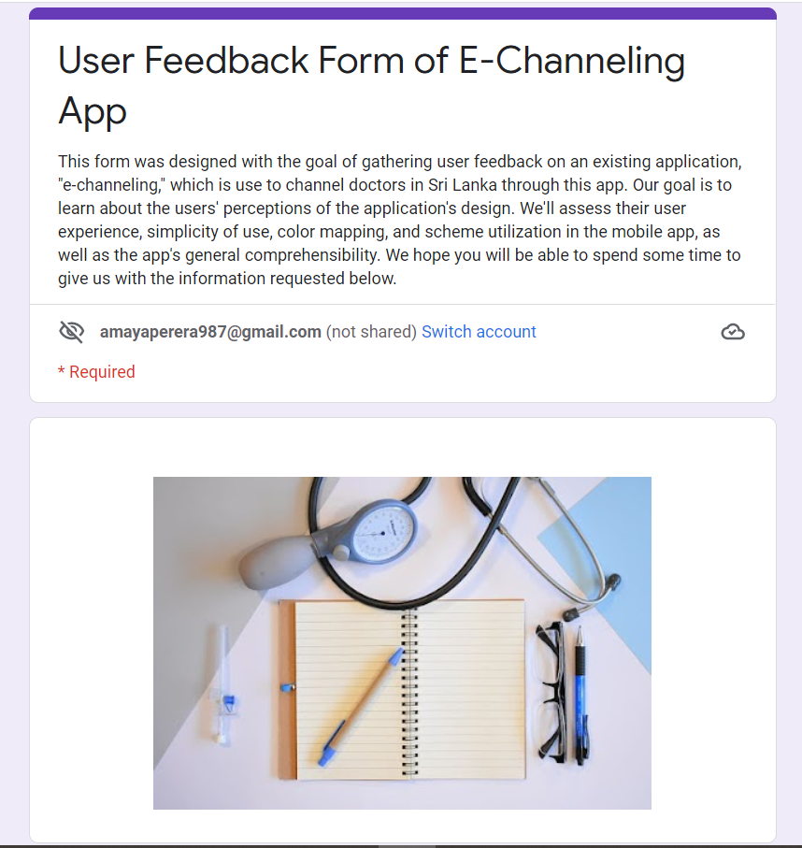

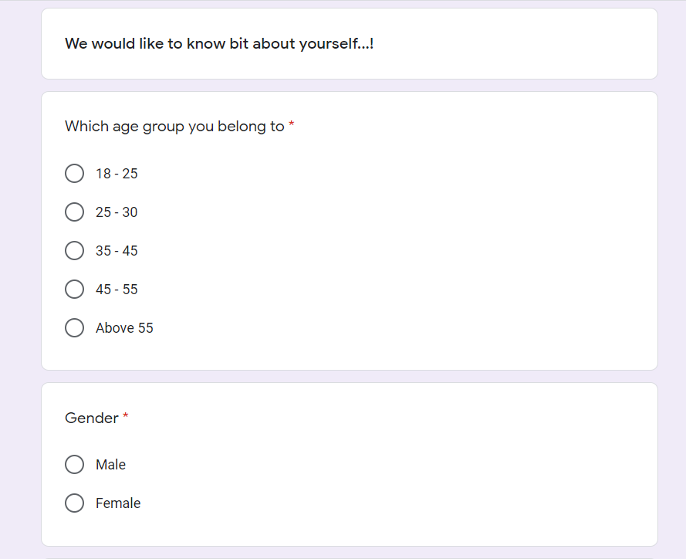

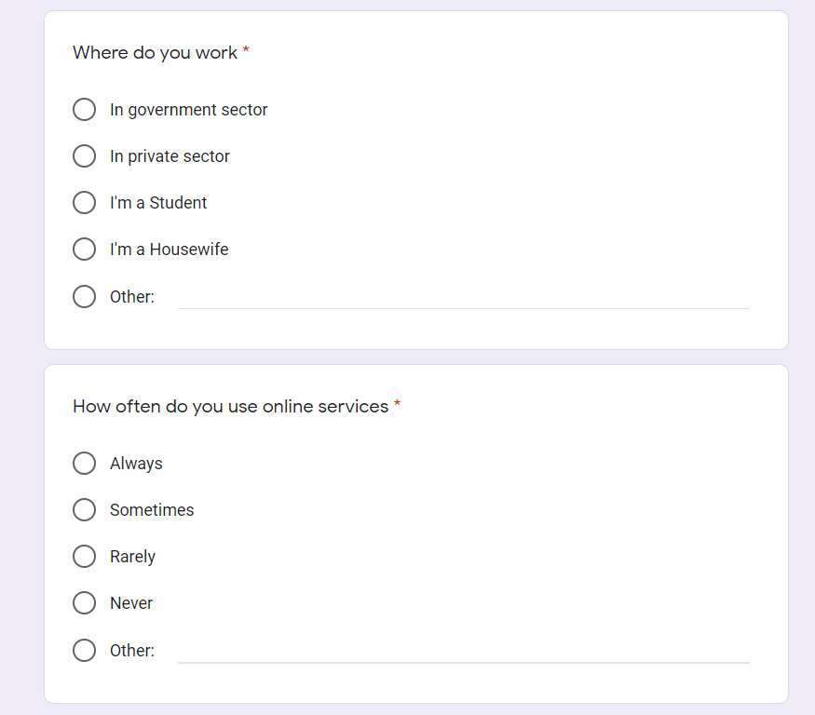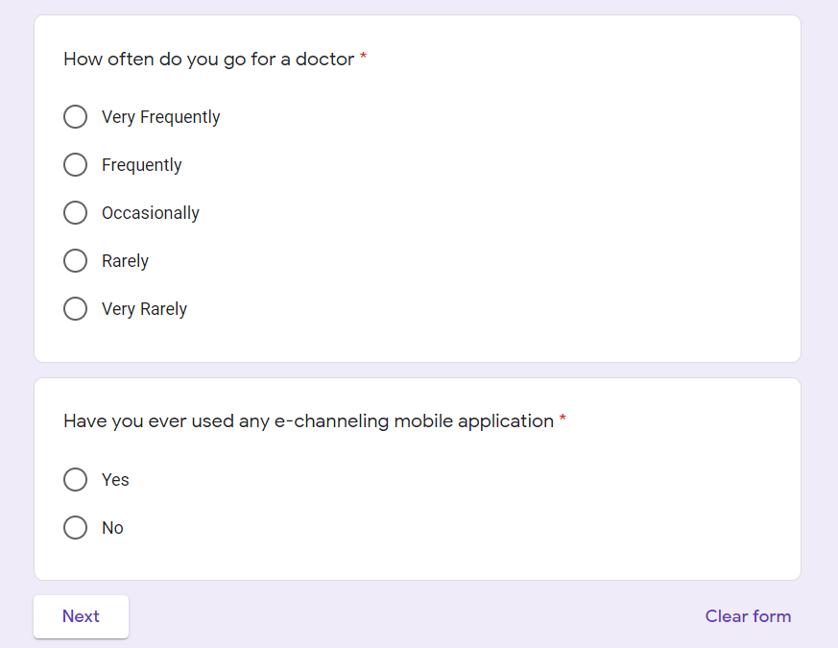

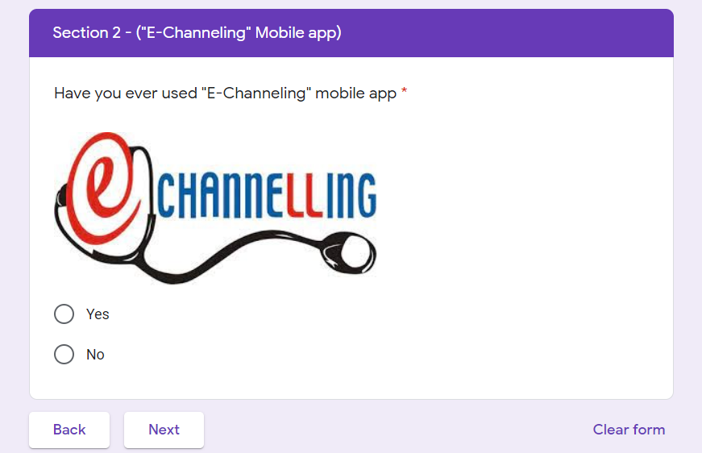

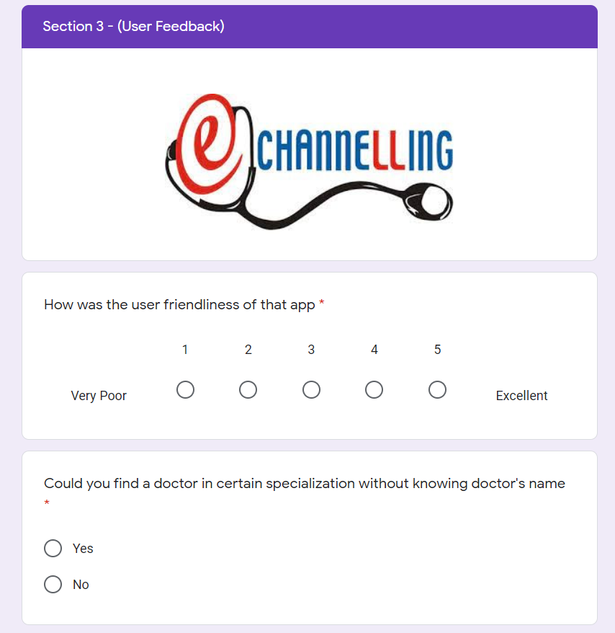

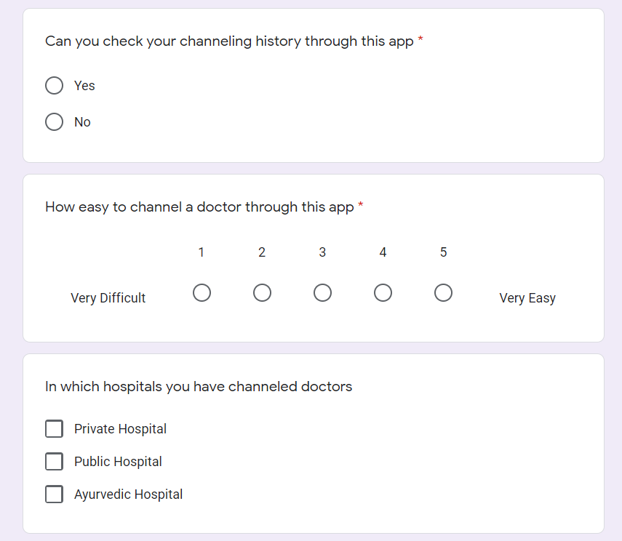

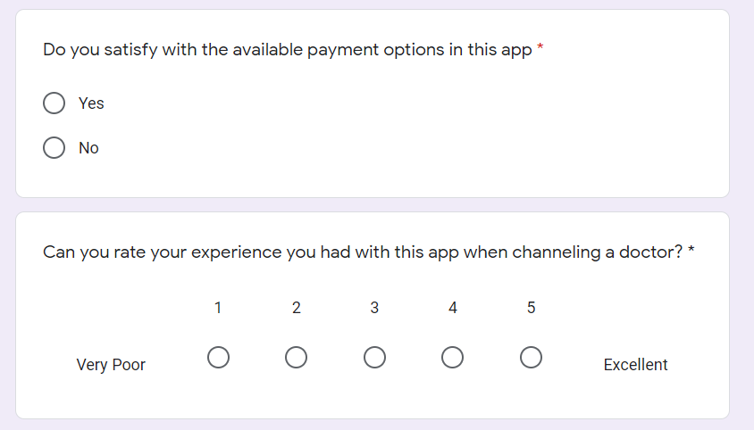

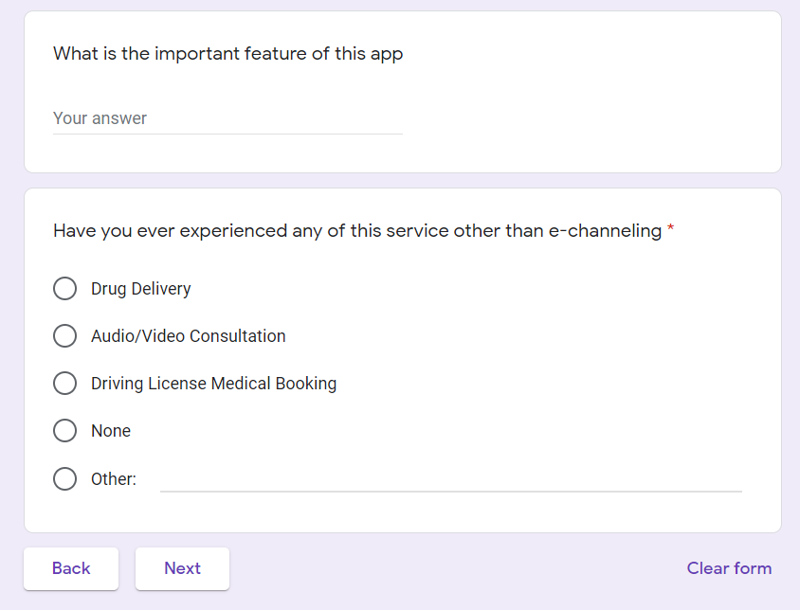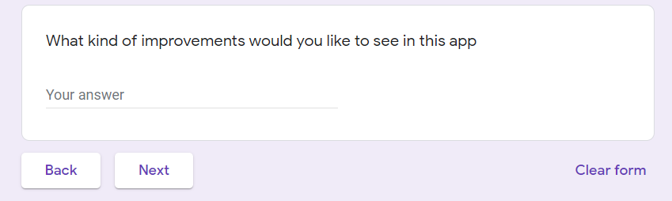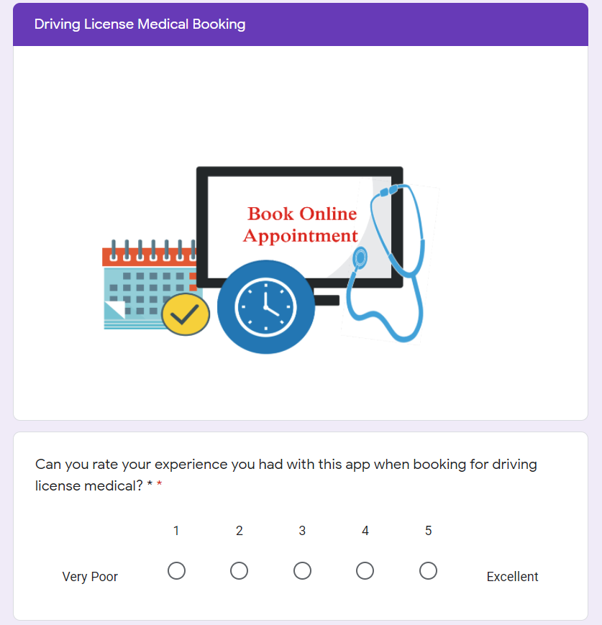

# Participant Profiles

|  |  |  |
| --- | --- | --- |
| Name | Demography | Location, Date, and Time |
|  | Age: years  Gender:  Marital Status: Single  Location:  Profession: | Location: Zoom Date: /08/2021 Time: |
| Menaya Nethsani | Age: 21  Gender: Female  Marital Status: Single  Location: Homagama  Profession: Student | Location: Zoom Date:23 /08/2021 Time: 3.30 p.m. |

# User Research – Task/ Scenarios

|  |  |  |  |
| --- | --- | --- | --- |
| **No.** | **Task Instruction** | **Target** | **Probes** |
| 01. | Sign up for the mobile  application. | Check the user experience of the  user while doing that process. |  |
| Log in to the mobile application. | Check, if the user can log in to the  application successfully. |  |
| Explore the application and ask  what he is thinks | Check whether the user can clearly  identify how the app is working. |  |
| Search for doctor. | Take the reaction of the user about  the User Interface. |  |
| Channel a doctor. | Identify the improvements of this  process. |  |
| Try to update the date and do the payment. | Check if the user can make changes  to appointment |  |
| Give feedback about the  booking. | Check if the user can give any  feedback about his/her channel. |  |
| 02. | Log in to the app. | Check the user experience of the  user while doing that process. |  |
| View profile and try to change  details. | Check, if the user can view the  profile and edit details easily. |  |
| View saved card details. | Try to view previously saved card details through the relevant  interface. |  |
| View the order history. | Identify the improvements of this  process and the user experience. |  |
| Try to add prescription. | Check if the user can add prescriptions to order medicine. |  |
| Try to contact relevant pharmacies via mobile app. | Try to check if the user can make  contact with support services easily. |  |

# Plan for Data analysis

# Interviews

## Participant 01

1.Can you share bit of yourself?

2.Have u use any service on this e-channeling app?

3.What do you think about the user friendliness of this application?

4.What do you think about the usability of this application?

5.What are the other services you have experienced in this app other than channeling a doctor?

6.According to your perspective what improvements you suggest doing?

7.If we consider the overall functionality, performance and design what do you think about this app?

## Participant 02

## Tell about yourself?

## I am Menaya Nethsani.I am 21 years old. I am doing a marketing diploma in SLIIM institute. I am in homagama.

## Have you ever used e channeling app?

## Yes

## Can you say for what ?

## To channel a doctor.

## Do you think this e-channeling app is better than comparing to manual doctor channeling or not?

## Yes, it’s better to channel a doctor than manually and its fast.

## Have you ever used drug delivery section of this app?

## Yes

## what are the difficulties you have faced during drug delivery and channel a doctor?

## That app was stuck, and some buttons are not clicked.

## what do you think about the user history interface in this application? Did you use it?

## Yes .history page is good. I can easily see my channelings and channel again.

## what do you think about the performance of this application? Is it good or worst?

**Video Recordings**

**Link for recording:**

**Questionnaires**

